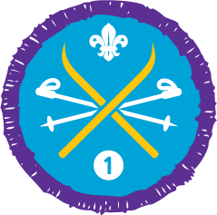
Snowsports - stage 2
How to earn your badge
Complete Snowsports Stage 1
Plus:

Identify the equipment you require and know how to carry it safely.

Climb and then ski or snowboard down a short run, or go on a short cross country ski.

Show you can make wide and narrow turns.

Show you can stop and wait safely on a run avoiding other users of the slope, or stop safely if doing cross county skiing.

Know how to safely fall and get back up onto your feet.

Choose 1 of the following options:

Demonstrate how to safely use a drag lift or magic carpet for downhill skiing or snowboarding.

Demonstrate your ability to identify a suitable cross country skiing route.

I confirm that................................................................has met the above stated

requirements for the Snowsports Stage 1 Badge

Signed.......................................................................... Date ......./......../...........

Print Name...........................................................................................

Place at which the assessment took

place..............................................................................

Please hand back to one of your Beaver/Cub/Scout Group Leaders.

